SEAVIEW INTEGRATED PRIMARY SCHOOL, GLENARM
PROCESS TO FOLLOW WHEN SUPPORTING YOUNG PEOPLE WHO ARE EXPERIENCING OR DISPLAYING
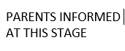
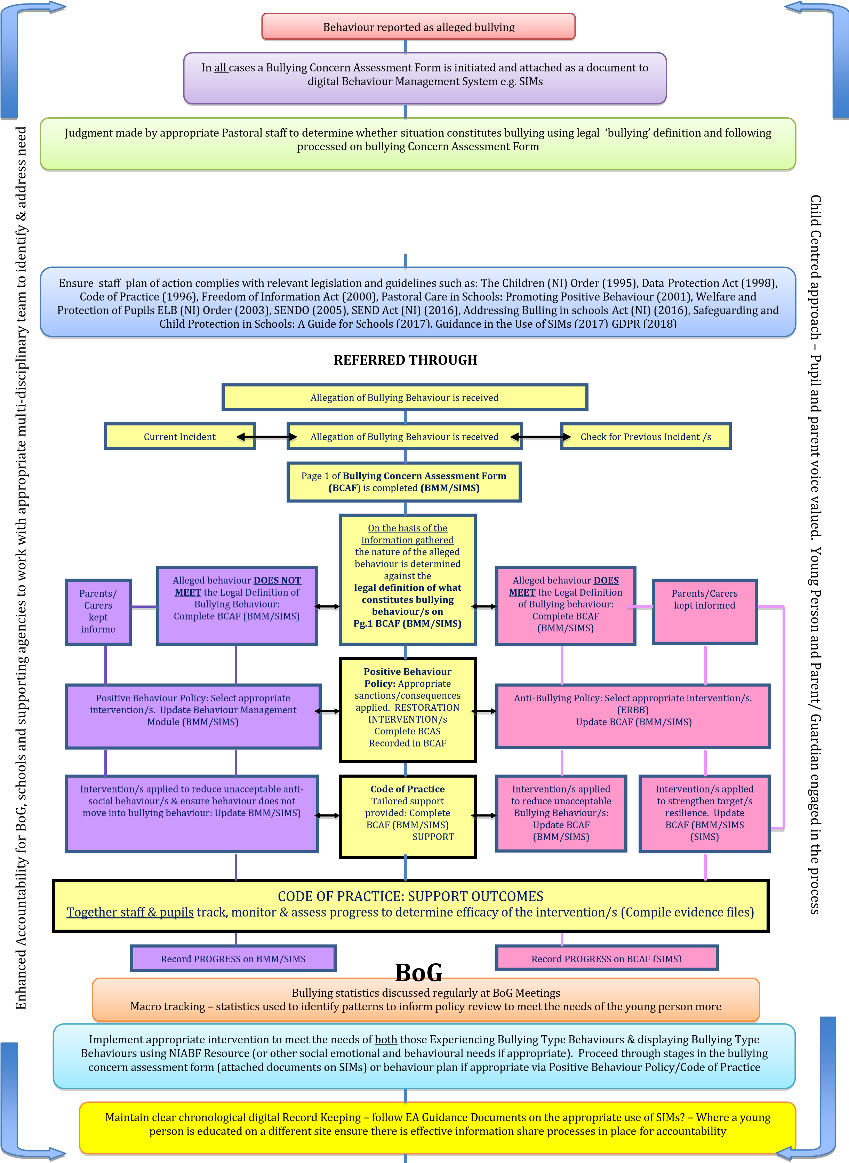
BULLYING TYPE BEHAVIOURS

